**Azure Storage Steps**

Steps to create Azure Storage Account with container:

Step1: Need to create one Storage Account with enable Network access “Enable public access from all networks”

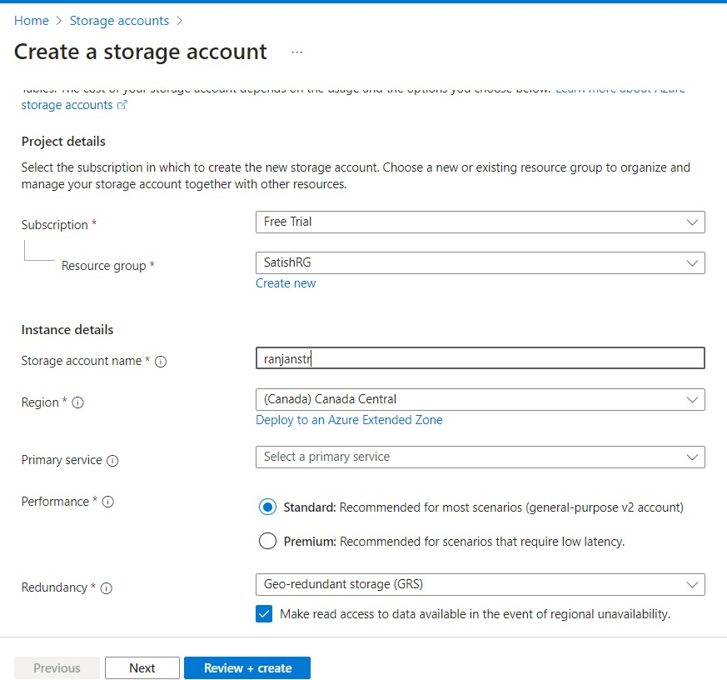

**How to Create Container and accessible over internet**

Step2: Create one container and upload one image in container

Step3: Click on 3 dots in the image and click on generate SAS, and then go to overview and copy URL and paste in browser to check image accessible over internet or not?

Note : But we cant able to access publicly due to permission issue, so need to authenticate by using below method:

Step4: We can also use Azure Storage Explorer software for Windows, linux and MAC for uploading, downloading purpose of any object.

Step5: For Accessing container image externally need to use Storage Account Keys method and SAS Method:

1. **Storage Account Keys Method** 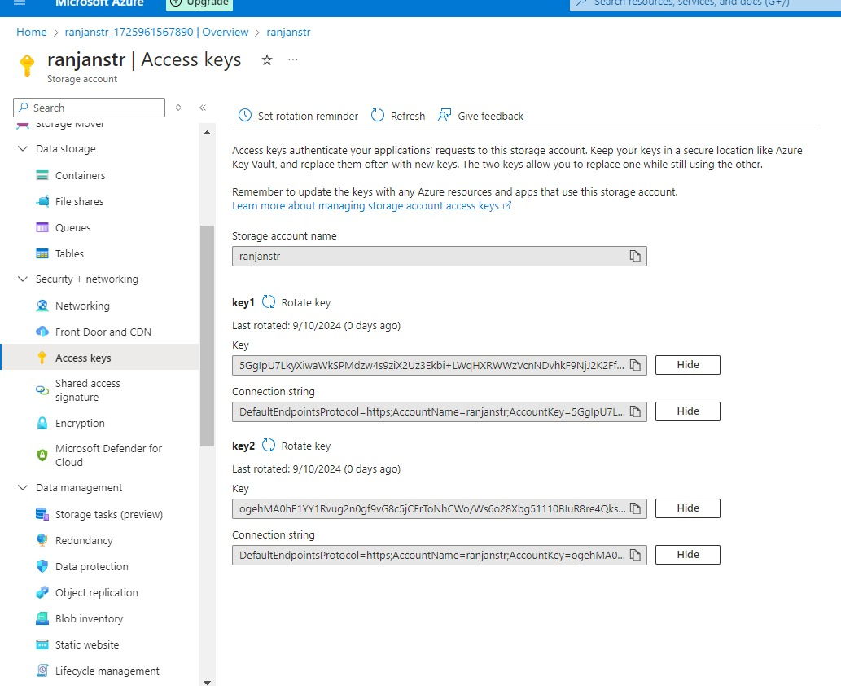
2. **SAS Method:**

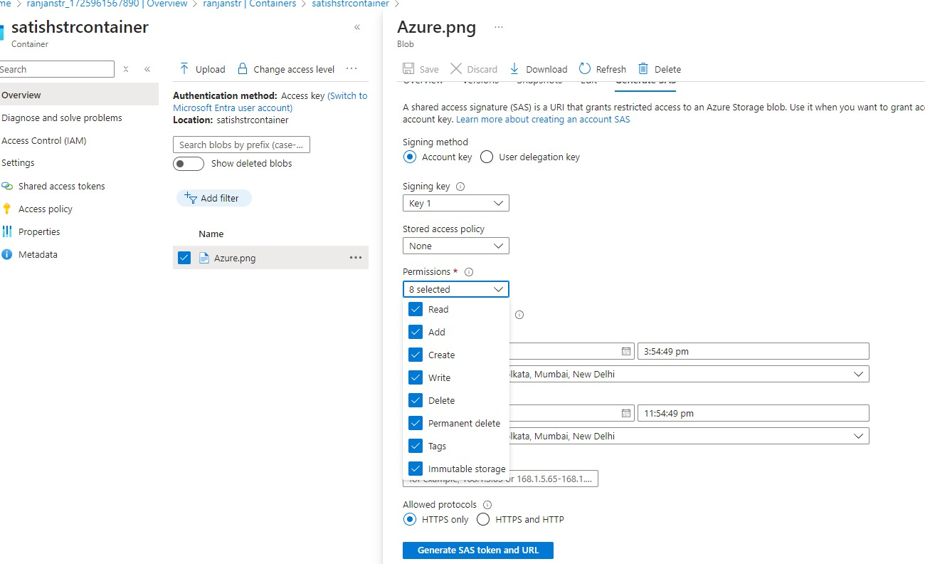

Step6: Now image accessible publicly

**How to Create File Share and check**

Step7: Go to File share in storage and then create one file share

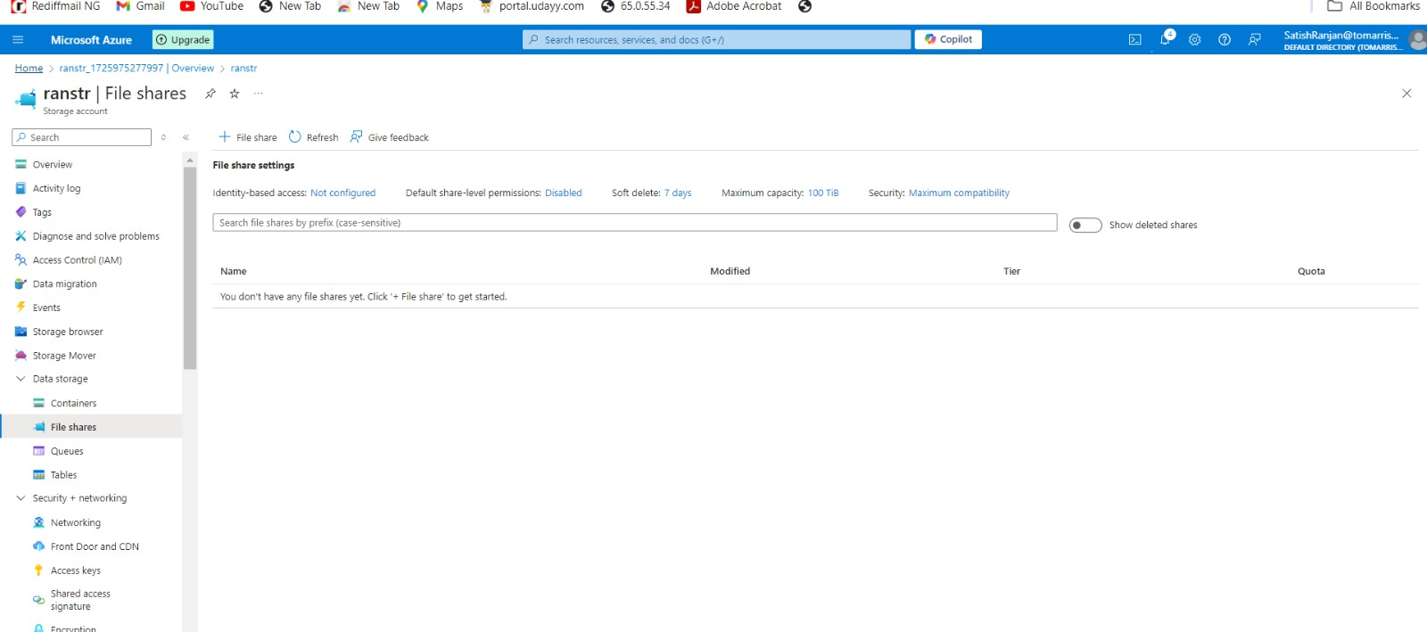

Step8: Click to connect and then create any drive for any OS like windows, linux and macos, here we are using for windows.

Step9: copy script for windows and run in powershell, we can use a new Azure windows VM or we can use our laptop windows

Step10: Now we check in our laptop a new drive showing in devices and drivers in network locations:

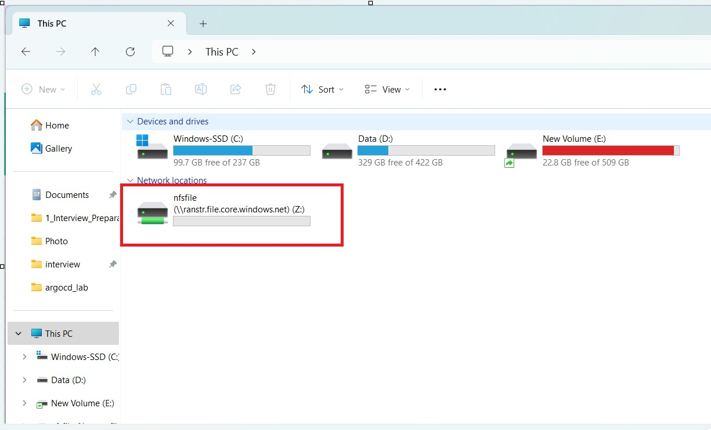

Step11: Now our storage container and SMB (Server Message Block) is publicly available

**How to Secure our Storage Container and SMB Block by using Service Endpoint**

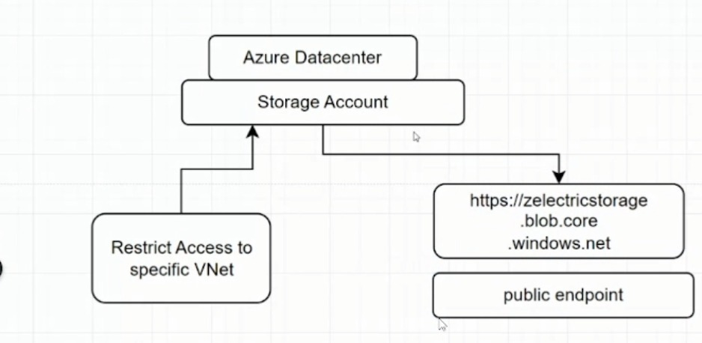

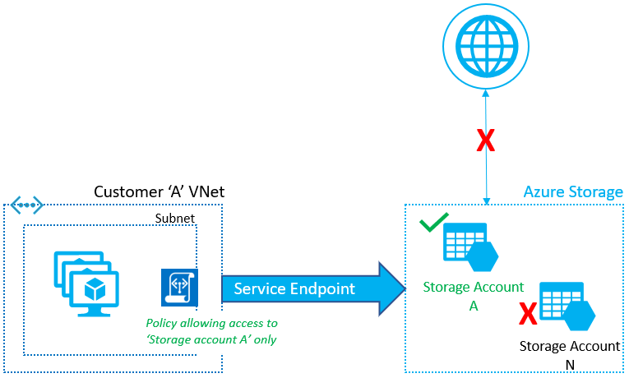

**Service Endpoint**

1. **Definition**: Service Endpoint ek Azure feature hai jo aapke virtual network (VNet) ko Azure ki specific services se securely connect karta hai.
2. **Kaise Kaam Karta Hai**: Jab aap Service Endpoint enable karte hain, toh aapke VNet ke resources (jaise virtual machines) directly Azure service (jaise Azure Storage, Azure SQL Database) ke saath communicate kar sakte hain. Yeh traffic public internet ke through nahi jata; instead, yeh Azure ki internal backbone network ke through hota hai, jo zyada secure aur reliable hota hai.
3. **Use Case**: Yeh generally tab use hota hai jab aap chahte hain ki aapke VNet ke resources ek specific Azure service ke saath secure connection banaye bina public internet ka use kiye.

**Private Endpoint**

1. **Definition**: Private Endpoint bhi ek Azure feature hai jo aapke VNet ke andar se ek private IP address assign karta hai, jisse aap Azure services ko directly aur securely access kar sakte hain.
2. **Kaise Kaam Karta Hai**: Private Endpoint ke through, Azure service (jaise Azure Storage ya SQL Database) ko aapke VNet ke andar ek private IP address diya jata hai. Iska matlab hai ki aapke VNet ke resources us private IP address ke through service se connect karte hain, jo ki public internet se bilkul bhi interact nahi karta.
3. **Use Case**: Yeh use hota hai jab aap chahte hain ki aapki Azure service ko sirf aapke VNet ke andar se access kiya ja sake aur internet se access nahi ho. Yeh extra security aur data privacy provide karta hai.

Service Endpoint ka use karne ke baad bhi, jo resources hain, wo publicly available hote hain. Yani ki, jab aap Service Endpoint enable karte hain, toh aapke VNet ke resources Azure ki specific service (jaise Azure Storage ya SQL Database) ke saath secure aur direct connection banate hain, lekin woh service abhi bhi public internet se accessible hoti hai.

Step12: First need to create one Subnet inside one VNET

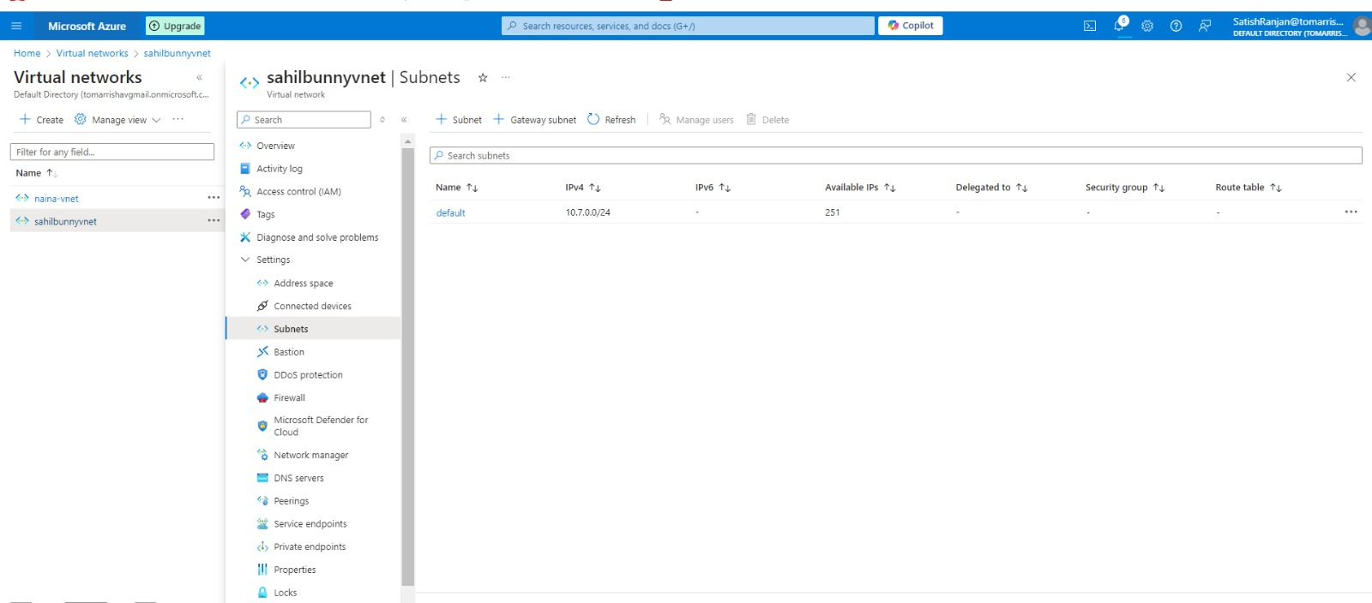

Step13: Need to choose service endpoints for PAAS Services which we want to securely access , here we are choosing Microsoft Storage Global.

Step14: Now need to go to Storage account, select our storage account and go to networking , then select vnet and subnet which we created for servicepoint

Step15: Now need to create one VM in same subnet which we already created in same subnet.

Step16: Now our storage container image is not accessible from internet publicly, it only accessible from VM which present in same subnet where service endpoint exist. For this we need to install Storage service explorer in VM and then try to connect and try to access our container image , it accessible publicly as well as we can connect through apps.